AI Resume & Interview Assistant: Personalized Career Preparation Using Generative AI
Generative AI Micro Project (7CS1018)

Submitted by
Chalini M – 2023BCSE07AED440
Spandana Basava Kulal – 2023BCSE07AED441

In partial fulfilment for the award of the degree of

BACHELOR OF TECHNOLOGY
In
COMPUTER SCIENCE AND ENGINEERING (DA)

Under the Supervision of

Dr. Marimganti Srinivas


ALLIANCE SCHOOL OF ADVANCED COMPUTING

ALLIANCE UNIVERSITY, BENGALURU NOVEMBER - 2026

ALLIANCE SCHOOL OF ADVANCED COMPUTING
ALLIANCE UNIVERSITY, BENGALURU
DEPARTMENT OF CSE (AI/ML)

----------------------------------------------------------------------------------------------------------

CERTIFICATE

This is to certify that the In-House Project work entitled “AI Resume & Interview Assistant: Personalized Career Preparation Using Generative AI” is the Bonafide work done by Chalini M (2023BCSE07AED440), Spandana Basava Kulal (2023BCSE07AED441) submitted in partial fulfilment of the requirements for the award of the degree Bachelor of Technology in Computer Science and Engineering during the
year 2026.

Supervisor
Associate Professor
Dept. of CSE (Specialization)

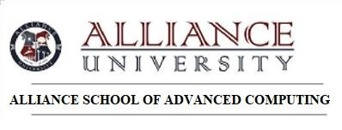

DECLARATION

This is to declare that the report titled “AI Resume & Interview Assistant: Personalized Career Preparation Using Generative AI” has been made for the partial fulfilment of the Programme - Bachelor of Technology in Computer Science and Engineering, under the guidance of Dr. Marimganti Srinivas. We confirm that this report truly represents my work undertaken as a part of our Gen AI Micro Project work. This work is not a replication of work done previously by any other person. We also confirm that the contents of the report and the views contained
therein have been discussed and deliberated with the Mentor.

NAME | REGESTRATION NO. | SIGNATURE
Chalini M | 2023BCSE07AED440
Spandana Basava Kulal | 2023BCSE07AED441

ACKNOWLEDGEMENT

The satisfaction that accompanies the successful completion of the task would be put incomplete without the mention of the people that made it possible, whose constant guidance and encouragement crown all the efforts successfully.
We are very thankful to my supervisor Dr. Marimganti Srinivas, Associate Professor for his sustained inspiring guidance and cooperation throughout the process of this project. Their wise counsel and valuable suggestions are invaluable.
We would like to thank Dr. K Rama Lakshmi, Head of the Department and Dr. V Vivek, Deputy Director, for their encouragement and cooperation at various levels of Project.
We avail this chance to express my deep sense of gratitude and hearty thanks to the Management of
Alliance University, for providing world class infrastructure, congenial atmosphere, and encouragement.
We express my deep sense of gratitude and because of the teaching and non-teaching staff at our department who stood with me during the project and helped me to make it a successful venture.
We place highest regards to my parents, my friends and well-wishers who helped plenty in making the report of this project.

Chalini M
Spandana Basava Kulal

ABSTRACT
The increasing competition in the job market has made resume optimization and interview preparation essential for job seekers. However, candidates often face difficulties in identifying the skills required for a particular job, aligning their resumes with job descriptions, and preparing for interviews effectively. Traditional approaches to career preparation are time-consuming and generally provide limited personalization.
This project presents an AI Resume & Interview Assistant: Personalized Career Preparation Using Generative AI, an intelligent application designed to support candidates throughout the job preparation process. The system uses Generative AI and Natural Language Processing techniques to analyze resumes and compare them with target job descriptions. It employs semantic similarity using Nomic Embeddings to identify the degree of alignment between candidate profiles and job requirements. The application also generates personalized resume improvement suggestions, identifies matching and unclear skills, and provides role-specific technical, project-based, and behavioral interview questions.
Furthermore, the system incorporates an adaptive interview chatbot powered by the Llama 3.2 language model through Ollama. It conducts interactive practice interviews by generating follow-up questions based on the candidate's responses. After the interview, the system produces an AI-generated evaluation report highlighting performance, strengths, areas for improvement, and a personalized learning plan. The application is developed using Python and Streamlit, with PyMuPDF for PDF-based resume text extraction.
The proposed system integrates resume analysis, resume improvement, interview preparation, adaptive interview practice, and performance feedback into a unified platform. It aims to make career preparation more personalized, accessible, and efficient while helping candidates identify skill gaps and improve their interview readiness.

LIST OF SYMBOLS & ABBREVIATIONS

CONTENTS

Page No
Title Page i
Certificate ii
Declaration iii
Acknowledgement iv
Abstract v
List of Symbols & Abbreviations vi

Contents
- Introduction 1
- Literature Review 3
- Identification of the Problem / Scope of the Project 5
- Proposed Idea / Solution 6
- Objectives of the Idea / Solution 7
- Process/Methodology 8
  - Identify the needs of customer and users through Design Thinking Methods.
  - Translate the needs of customer into Project / Product.
  - Specification of the Project / Product
  - Designing the solution for the customer needs.
- Requirements 10
  - Hardware Requirements
  - Software Requirements
  - Datasets (If any)
  - Technologies and Tools
- Process / Flow / Design Diagram 12
- Proposed Modules 13
- Novelty of the Proposed Idea / Project 15
- Conclusion 16
References 17
Publication Proof ( Submission Copy) 19
Plagiarism Report 20

INTRODUCTION
In today's competitive job market, securing employment requires more than academic qualifications. Candidates must present their skills effectively through well-structured resumes and demonstrate their technical knowledge, communication abilities, and problem-solving skills during interviews. However, many job seekers face challenges in preparing resumes according to specific job requirements and practicing for interviews in a structured and personalized manner.
Traditional resume preparation involves manually reviewing job descriptions, identifying relevant skills, modifying resume content, and preparing possible interview questions. This process can be time-consuming and may not always provide sufficient guidance about skill gaps or areas that require improvement. Similarly, conventional interview preparation methods often rely on generic question banks that do not consider an individual's resume, projects, or target job role.
To address these challenges, the AI Resume & Interview Assistant is developed as a Generative AI-based application that provides personalized career preparation support through an integrated platform. The system uses Natural Language Processing (NLP), semantic similarity techniques, and Large Language Models (LLMs) to analyze candidate resumes

2. PROBLEM STATEMENT, OBJECTIVES AND SCOPE
3.1 Problem Statement
In the current competitive employment environment, candidates often face difficulties in preparing resumes that align with specific job descriptions and identifying the skills required for their desired positions. Manually comparing resumes with job requirements, identifying skill gaps, improving resume content, and preparing for interviews can be time-consuming and challenging.
Existing interview preparation resources frequently provide generic questions that do not consider an individual's technical background, projects, skills, or target job role. Additionally, candidates may lack an effective mechanism to evaluate their interview responses and identify areas that require further improvement.
Therefore, there is a need for an integrated AI-based system that can analyze resumes against job descriptions, identify matching and unclear skills, suggest relevant resume improvements, generate personalized interview questions, conduct adaptive practice interviews, and provide performance feedback to support continuous career preparation.
3.2 Objectives
The primary objective of this project is to develop an AI-powered resume and interview assistant that provides personalized career preparation using Generative AI and Natural Language Processing techniques.
The specific objectives are:
- Resume Text Extraction: To extract relevant information from PDF resumes using PyMuPDF for further analysis.
- Resume and Job Description Analysis: To compare candidate resumes with target job descriptions using semantic similarity techniques and identify their alignment.
- Skill Matching and Gap Identification: To identify matching skills, missing or unclear requirements, and weakly represented skills based on resume evidence.
- Resume Improvement: To generate role-specific suggestions and improve existing resume bullet points while maintaining the accuracy of candidate information.
- Personalized Interview Preparation: To generate technical, project-based, and behavioral interview questions according to the candidate's resume and target job role.
- Adaptive Interview Practice: To develop an interactive chatbot that generates relevant follow-up questions based on the candidate's previous responses.
- Interview Performance Evaluation: To evaluate submitted interview responses and generate feedback highlighting strengths and areas for improvement.
- Personalized Learning Plan: To recommend relevant topics, practice questions, and learning activities based on the interview evaluation.
3.3 Scope of the Project
The scope of the proposed system covers the integration of AI-based resume analysis and personalized interview preparation into a single application.
The major functionalities included within the project scope are:
- Resume Upload and Processing: Supports uploading PDF resumes and extracting selectable text for analysis.
- Job Description Input: Allows candidates to enter their target job role and paste the corresponding job description.
- Semantic Similarity Analysis: Uses Nomic Embeddings to calculate semantic similarity between resume content and job description requirements.
- Resume Analysis: Generates a structured report containing resume summaries, job requirements, matching skills, unclear requirements, and overall assessment.
- Resume Enhancement Suggestions: Provides recommendations for improving resume content, formatting, clarity, and role-specific relevance.
- Interview Question Generation: Generates personalized technical, project-based, and behavioral questions.
- Interactive Interview Chatbot: Conducts practice interviews using the Llama 3.2 language model through Ollama and generates adaptive follow-up questions.
- Feedback and Evaluation: Produces AI-generated interview feedback based on submitted answers, including approximate performance assessments and improvement areas.
- Learning Recommendations: Provides a personalized learning plan to help candidates improve their knowledge and interview performance.
- Report Download: Allows users to download generated resume improvement, interview preparation, and evaluation reports.
The application is developed using Python and Streamlit, with Ollama for local language model processing, Nomic Embeddings for semantic similarity, and PyMuPDF for PDF text extraction.

3. LITERATURE REVIEW / EXISTING SYSTEMS
The following research papers provide a foundation for AI-based resume analysis and personalized interview preparation.

Research Paper | Contribution to Our Project
Human and LLM-Based Resume Matching: An Observational Study (NAACL 2025) | Studies LLM-based resume evaluation and highlights challenges such as inaccurate ratings and bias.
EZInterviewer: To Improve Job Interview Performance with Mock Interview Generator (WSDM 2023) | Generates personalized interview questions using candidate resumes, job descriptions, and conversation history.
PolyInterview: An LLM-based Platform for Immersive Mock Interview Practice with Comprehensive Multimodal Assessment (2026) | Combines personalized mock interviews, adaptive follow-up questions, and structured performance feedback.

These studies demonstrate the potential of LLMs for resume matching and interview preparation. Our project combines resume analysis, skill-gap identification, resume improvement, adaptive mock interviews, and personalized feedback in one platform.

4. PROPOSED METHODOLOGY AND SYSTEM ARCHITECTURE
4.1 Overall Workflow
The proposed system follows an integrated workflow consisting of resume analysis, job description matching, skill-gap identification, resume improvement, personalized interview preparation, and performance evaluation.
Initially, the candidate uploads a resume in PDF format and enters the target job role along with the job description. The system extracts the resume text using PyMuPDF and processes the provided information. The extracted resume content and job description are converted into semantic embeddings using the Nomic Embedding model. Cosine similarity is used to estimate semantic relevance between the resume and job description.
The Llama 3.2 language model analyzes the extracted information to identify matching skills, missing requirements, relevant experience, and areas requiring improvement. Based on this analysis, the system generates personalized resume improvement suggestions and interview preparation questions. During the mock interview, the system generates questions based on the candidate's resume and target job role. It also generates follow-up questions based on the candidate's previous answers to simulate an interactive interview experience.
Finally, the system evaluates the interview responses and generates a performance report containing scores, strengths, improvement areas, practice questions, and a personalized learning plan.
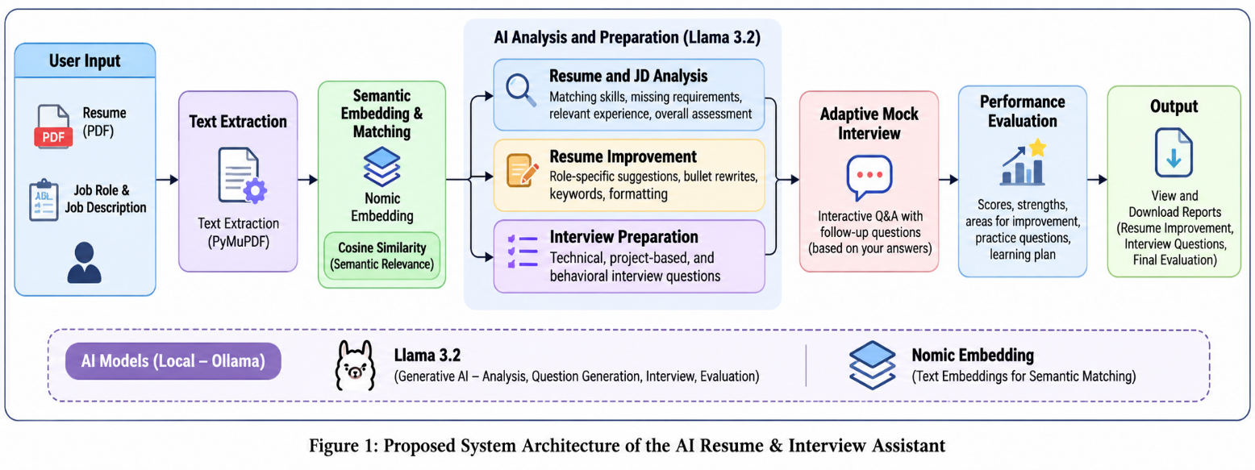

Figure 1. Proposed System Architecture:

4.2 Main Components
Component | Purpose
Resume Upload | Accepts the candidate's resume in PDF format.
Text Extraction | Extracts textual information from the uploaded resume using PyMuPDF.
Job Description Input | Collects the target job role and job description.
Embedding Model | Generates semantic embeddings using Nomic Embedding.
Resume Matcher | Calculates cosine similarity between resume and job description embeddings.
Resume Analyzer | Identifies matching skills, missing requirements, and relevant experience using Llama 3.2.
Resume Improvement Module | Generates suggestions to improve resume content and highlight relevant skills.
Interview Preparation Module | Generates role-specific technical, project-based, and behavioral questions.
Adaptive Interview Module | Generates interview questions and follow-up questions based on candidate responses.
Evaluation Module | Evaluates interview responses and identifies strengths and improvement areas.
User Interface | Displays analysis results, interview interactions, and downloadable reports using Streamlit.

4.3 Processing and Generation Procedure
Step 1: Resume Upload. The candidate uploads a PDF resume through the application interface.
Step 2: Text Extraction. PyMuPDF extracts the textual content from the uploaded resume.
Step 3: Job Description Input. The candidate enters the target job role and corresponding job description.
Step 4: Semantic Matching. The resume and job description are converted into embeddings using Nomic Embedding. Cosine similarity is calculated to estimate their semantic relevance.
Step 5: Resume and Skill Analysis. Llama 3.2 analyzes the resume and job description to identify matching skills, missing requirements, and areas requiring improvement.
Step 6: Resume Improvement. The system generates personalized recommendations, including content improvements and relevant keywords without inventing qualifications or experience.
Step 7: Interview Preparation. The system generates technical, project-based, and behavioral interview questions based on the candidate's profile and target role.
Step 8: Adaptive Mock Interview. The candidate answers generated questions, and the LLM produces relevant follow-up questions based on previous responses.
Step 9: Performance Evaluation. The system analyzes the interview transcript and generates an evaluation report containing performance scores, strengths, weaknesses, and improvement suggestions.
Step 10: Feedback and Output. The candidate receives a downloadable evaluation report and personalized learning recommendations.

5. TOOLS, TECHNOLOGIES AND KNOWLEDGE SOURCES
Layer | Technology Used
Programming Language | Python
Large Language Model | Llama 3.2
AI Model Runtime | Ollama
Embedding Model | Nomic Embedding (nomic-embed-text)
Semantic Similarity | Cosine Similarity
Application Framework | Streamlit
PDF Processing | PyMuPDF
API Communication | Python Requests
Development Environment | Visual Studio Code

5.1 Knowledge Sources / Dataset
The system does not use a separate model-training dataset. It uses user-provided PDF resumes and job descriptions as input sources for analysis. Candidate interview responses are also used to generate personalized feedback and performance evaluation. The system processes this information using locally running AI models through Ollama.
5.2 Reproducibility Details
The application is developed using Python and Streamlit. Llama 3.2 and Nomic Embedding are executed locally through Ollama. PyMuPDF is used for PDF text extraction, while the Requests library communicates with the Ollama API. Reproducing the system requires Python, the required Python packages, Ollama, and the specified models to be installed and configured.

6. IMPLEMENTATION
The AI Resume & Interview Assistant is implemented using Python and Streamlit, integrating locally hosted AI models through Ollama.
6.1 Data Preparation
The system accepts PDF resumes and job descriptions from users. PyMuPDF extracts text from uploaded resumes, which is then prepared for further analysis.
6.2 Embedding and Similarity Analysis
The Nomic Embedding model converts resume content and job descriptions into numerical embeddings. Cosine similarity is used to measure their semantic relevance.
6.3 Resume and Job Description Analysis
Llama 3.2 analyzes resume information and job requirements to identify matching skills, missing or unclear requirements, and relevant experience.
6.4 LLM Integration
Ollama is used to run the Llama 3.2 model locally. The model generates resume improvement suggestions, interview questions, adaptive follow-up questions, and interview evaluation reports.
6.5 User Interface
The application is developed using Streamlit. Its interface provides PDF upload, job description input, resume analysis, improvement suggestions, interview preparation, an interactive interview chatbot, and downloadable evaluation reports.
6.6 Error Handling
The application handles invalid PDF uploads, empty resume content, missing job descriptions, and Ollama API connection or response errors. It also provides error messages when AI-generated operations fail.

7. EXPERIMENTS, RESULTS AND DISCUSSION
7.1 Evaluation Design
The system is evaluated by testing its major functionalities using different resumes and job descriptions. The evaluation focuses on resume analysis, semantic similarity, skill matching, resume improvement, interview question generation, adaptive interview performance, and feedback generation.
Evaluation Metrics
Metric | What It Measures
Semantic Similarity | Measures the relevance between resume content and job description using cosine similarity.
Skill Matching | Checks whether relevant job requirements are identified in the resume.
Resume Improvement Quality | Evaluates the relevance and usefulness of generated resume suggestions.
Question Relevance | Measures how well generated interview questions match the candidate's profile and target role.
Adaptive Interview Performance | Checks whether follow-up questions consider previous candidate responses.
Evaluation Quality | Assesses the relevance and usefulness of generated interview feedback.
Response Time | Measures the time taken by the application to complete AI operations.
User Feedback | Collects feedback on usability and the usefulness of the generated results.

7.2 Results and Discussion
The application successfully demonstrates resume text extraction, resume and job description analysis, personalized resume improvement suggestions, interview question generation, adaptive interview conversations, and AI-generated evaluation reports.
The results demonstrate how Generative AI can support personalized career preparation through an integrated application. However, semantic similarity and AI-generated evaluation scores are approximate and require further validation using a larger test set and user feedback.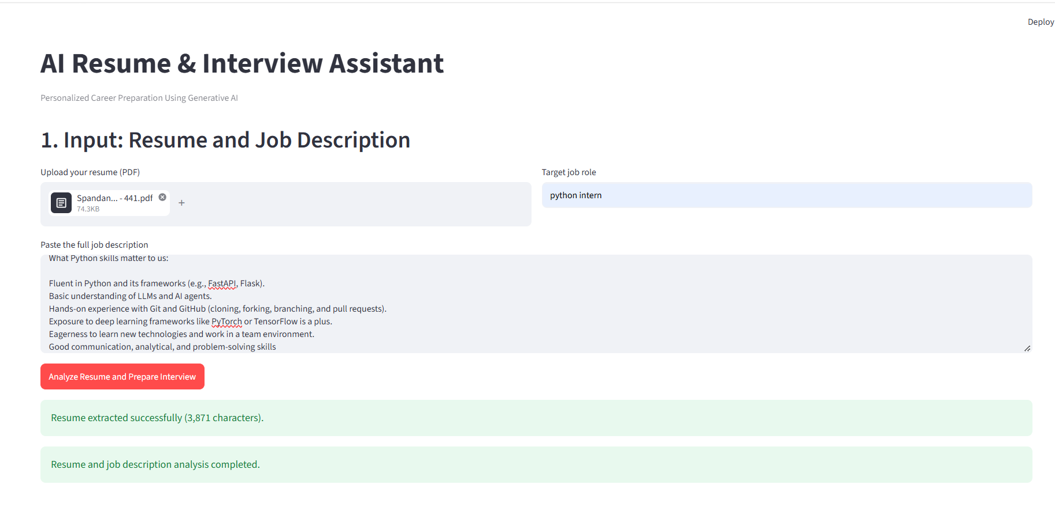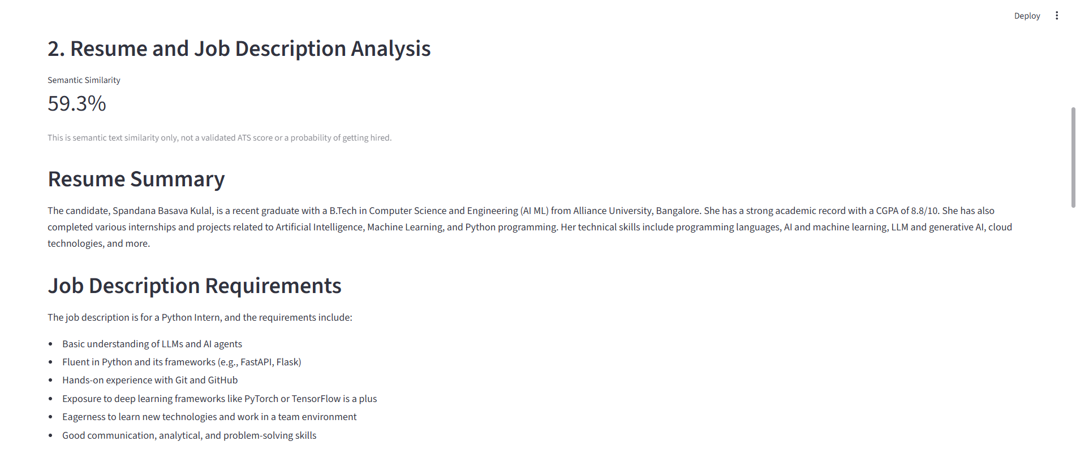 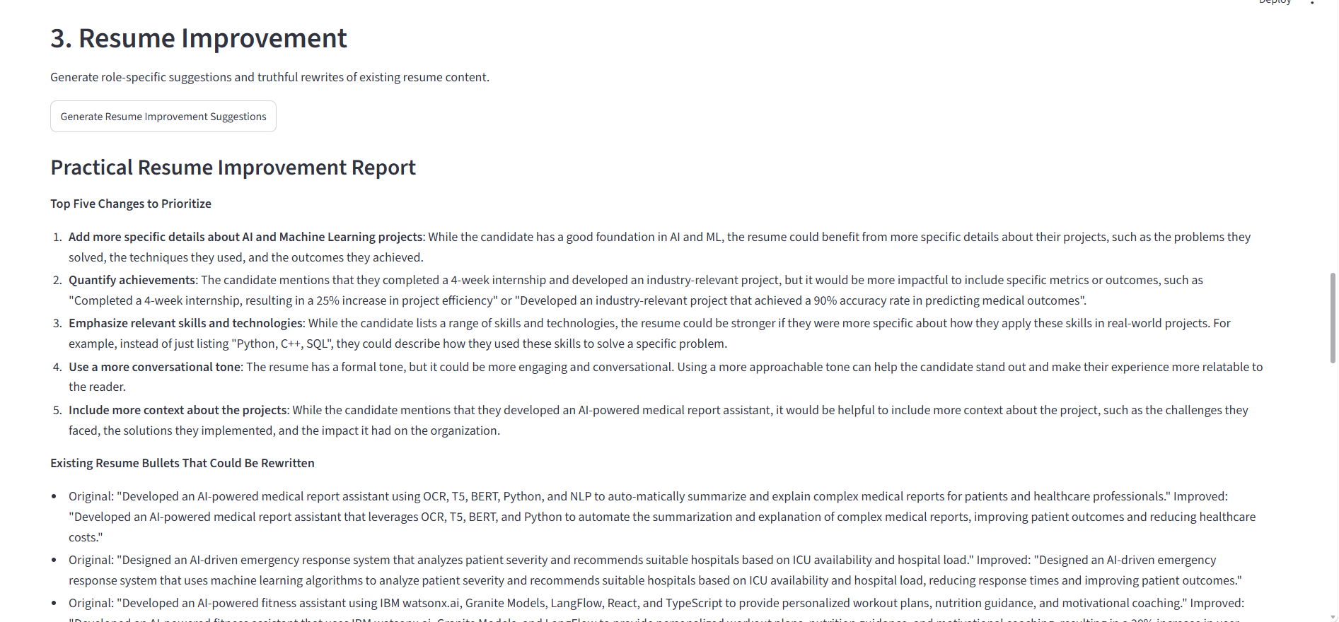

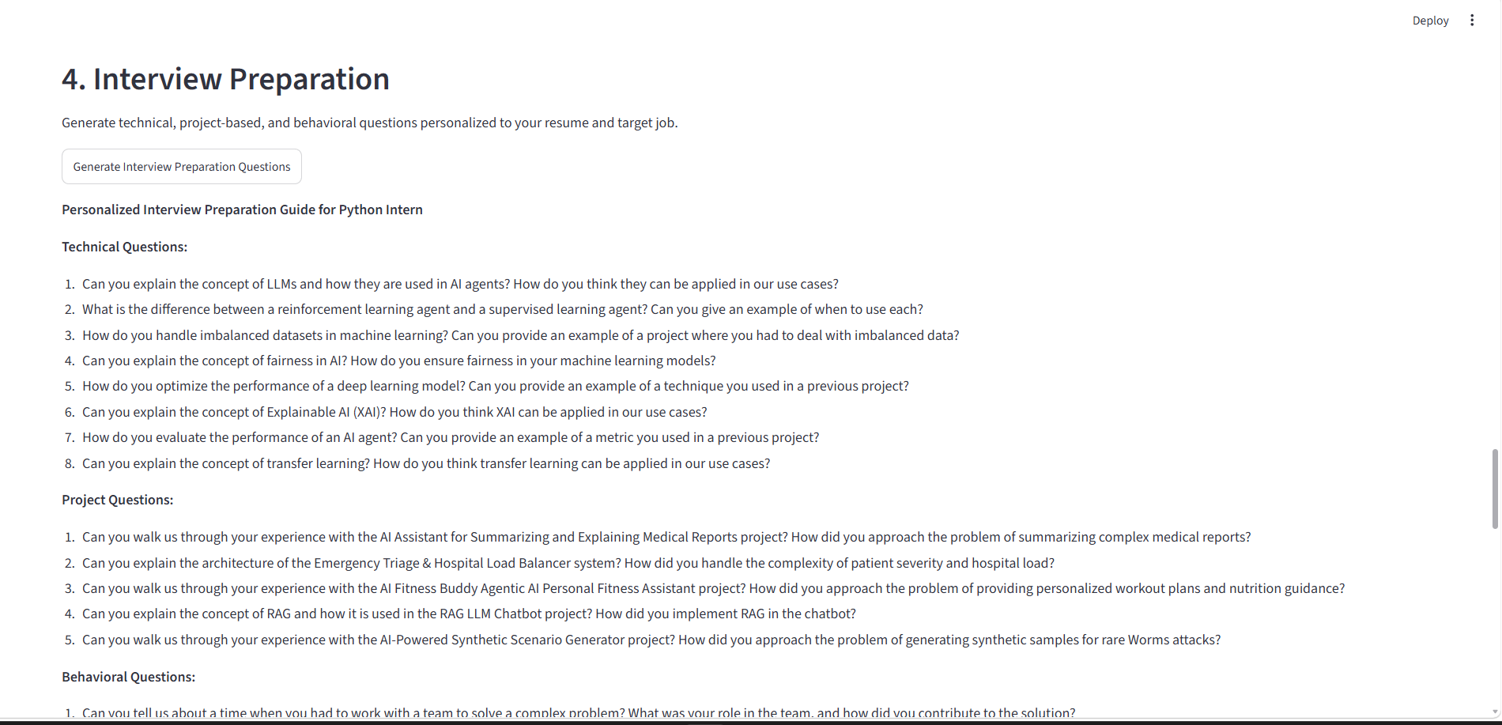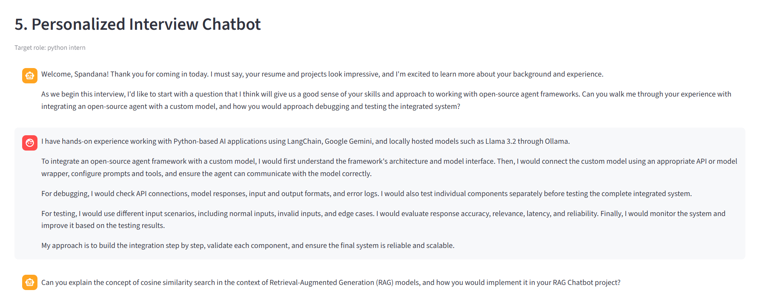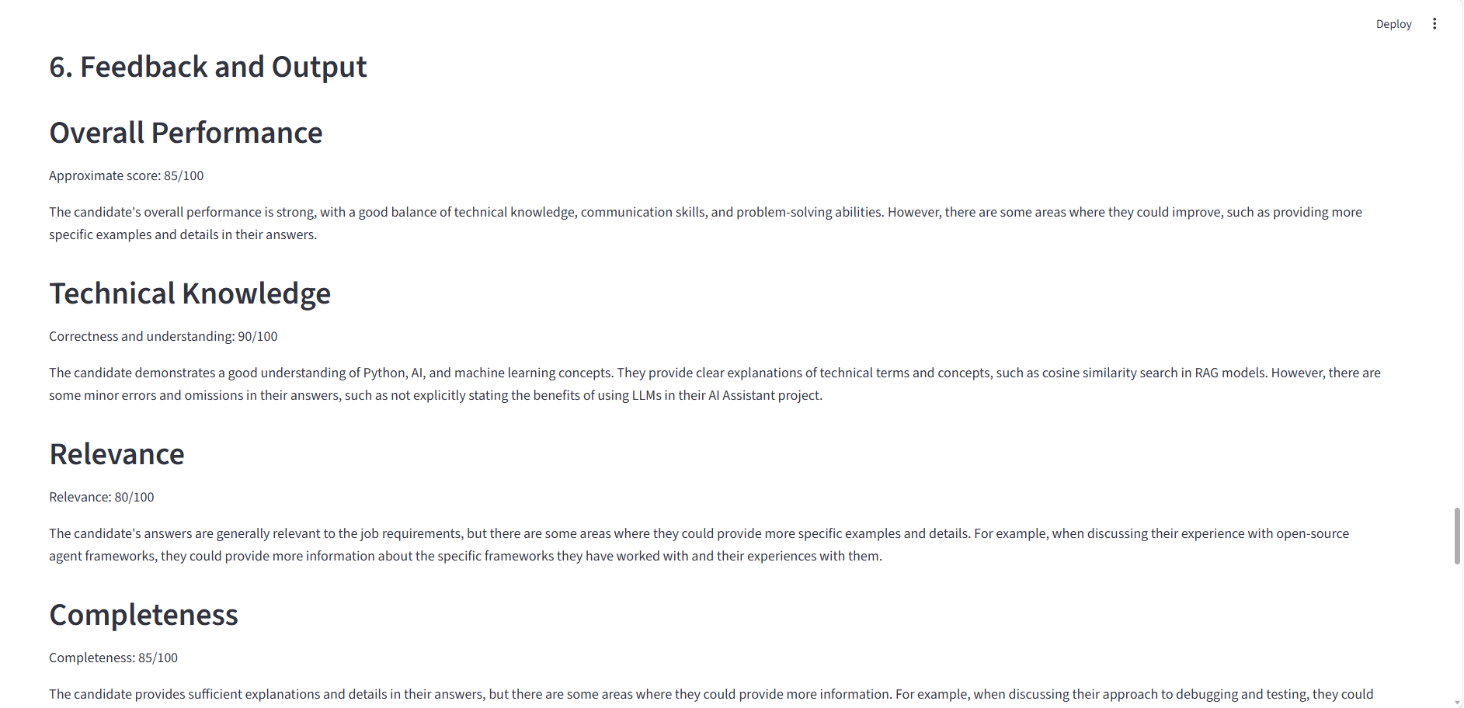

8. Limitations, Ethical Considerations and Risk Mitigation
Although the proposed Retrieval-Augmented Generation (RAG) system provides context-aware responses based on retrieved documents, it has certain limitations that may affect its performance and reliability.
  - Limitations
- The system may generate incorrect, incomplete, or irrelevant responses if the retrieved information is insufficient.
- Poor-quality, scanned, or incorrectly formatted PDF documents may affect text extraction and retrieval accuracy.
- The retrieval process may fail to identify relevant information when documents contain complex terminology or ambiguous content.
- The language model may occasionally generate unsupported information (hallucinations) despite being provided with retrieved context.
- The system's performance depends on the quality, completeness, and availability of the uploaded documents.
8.2 Ethical Considerations
The system must be developed and used responsibly to ensure data privacy, transparency, and reliability.
- Only authorized documents should be uploaded and processed.
- Source references should be displayed wherever possible to support answer verification.
- The system should clearly communicate when information is unavailable in the indexed documents.
- Confidential academic, personal, or institutional information must be protected.
- External language model APIs should be used with proper consideration of data privacy and retention policies.
- The system should be tested against prompt injection attacks and malicious instructions embedded in uploaded documents.

8.3 Risk Mitigation Strategies
To minimize potential risks, the following measures are considered:
- Validate uploaded documents before processing.
- Apply appropriate text cleaning and preprocessing techniques.
- Use reliable embedding models and similarity-based retrieval techniques.
- Restrict answer generation to the retrieved context wherever possible.
- Implement error handling for missing documents, API failures, and invalid user inputs.
- Evaluate the system using different test queries to measure retrieval quality and response accuracy.

9. Conclusion and Future Enhancements
9.1 Conclusion
The proposed Retrieval-Augmented Generation (RAG) system demonstrates how Large Language Models (LLMs) can be integrated with document retrieval techniques to provide context-aware responses from a predefined collection of documents.
The system combines document ingestion, text extraction, chunking, embedding generation, vector-based similarity search, and language model-based response generation. By retrieving relevant information before generating responses, the approach aims to improve the relevance and contextual accuracy of answers compared with conventional prompt-based question answering.
The project provides a practical implementation of document-based question answering and demonstrates the potential of Generative AI in academic and administrative information retrieval. However, the reliability of the generated responses depends on document quality, retrieval performance, and the capabilities of the selected language model.
9.2 Future Enhancements
The following improvements can be considered in future versions of the system:
- Multilingual Support: Extend the system to support multiple languages for broader accessibility.
- OCR Integration: Implement Optical Character Recognition (OCR) to extract information from scanned PDF documents and images.
- Hybrid Search: Combine keyword-based retrieval with semantic search to improve document retrieval accuracy.
- Conversation Memory: Maintain conversation history to support contextual follow-up questions.
- Access Control: Introduce role-based authentication to protect confidential documents.
- Advanced Evaluation: Implement automated evaluation metrics to measure retrieval relevance, answer accuracy, and hallucination rates.
- Scalability: Optimize the vector database and deployment architecture to handle larger document collections and multiple users.

REFERENCES
[1] P. Lewis et al., "Retrieval-Augmented Generation for Knowledge-Intensive NLP Tasks," Advances in Neural Information Processing Systems, vol. 33, pp. 9459–9474, 2020.
[2] N. Reimers and I. Gurevych, "Sentence-BERT: Sentence Embeddings using Siamese BERT-Networks," in Proceedings of the 2019 Conference on Empirical Methods in Natural Language Processing and the 9th International Joint Conference on Natural Language Processing (EMNLP-IJCNLP), 2019, pp. 3982–3992.
[3] J. Johnson, M. Douze, and H. Jégou, "Billion-scale similarity search with GPUs," IEEE Transactions on Big Data, vol. 7, no. 3, pp. 535–547, 2019.
[4] A. Vaswani et al., "Attention Is All You Need," in Advances in Neural Information Processing Systems, vol. 30, 2017.

